Core Benefits of Game Analytics
- Player Retention Optimization: Identify why players leave and when they're most likely to churn, enabling targeted retention campaigns
- Revenue Maximization: Understand which monetization strategies work best for different player segments and optimize pricing
- Feature Validation: Test new features with small player segments before full rollout, reducing risk and development waste
- Gameplay Balancing: Identify overpowered mechanics, underused features, and progression bottlenecks through behavioral data
- Marketing Attribution: Track which acquisition channels bring the highest-value players and optimize marketing spend accordingly
- Player Segmentation: Create targeted experiences for different player types based on behavior patterns and preferences
一、游戏数据分析的核心价值
优化玩家留存：定位玩家流失原因与高流失节点，针对性开展留存运营活动。
收益最大化：分析不同变现策略对各类玩家群体的效果，完成定价优化。
功能效果验证：先向小部分玩家上线新功能进行测试，再全面推广，降低风险与开发损耗。
游戏玩法平衡：依托玩家行为数据，找出强度失衡的机制、使用率偏低的功能以及进度卡点。
营销效果归因：追踪各获客渠道带来的高价值玩家，据此优化营销预算分配。
玩家分层运营：根据行为模式与偏好，为不同类型玩家打造定制化游戏体验。
Modern game analytics has evolved from simple download tracking to sophisticated systems that analyze player psychology, predict future behavior, and enable real-time personalization. Leading studios now employ dedicated analytics teams that work alongside designers, product managers, and live operations specialists to continuously optimize the player experience. For indie developers, even basic analytics implementation can provide competitive advantages that rival larger studios.
现代游戏数据分析早已不再局限于简单的下载量统计，如今已发展为一套成熟体系：分析玩家心理、预判后续行为，并实现实时个性化运营。头部游戏工作室都会组建专职数据分析团队，与游戏设计师、产品经理、线上运营人员协作，持续优化玩家体验。对于独立开发者而言，即便仅部署基础数据分析功能，也能获得足以媲美大型工作室的竞争优势。
Key Game Metrics & KPIs by Genre
Understanding which metrics to track depends heavily on your game genre, business model, and development stage. While some metrics apply universally across all games, others are specific to particular game types or monetization strategies. This section breaks down essential KPIs by category and provides benchmarks for different game genres to help you evaluate your game's performance against industry standards.

二、按游戏品类划分的核心指标与关键绩效指标（KPI）
选择追踪哪些指标，很大程度上取决于游戏品类、商业模式以及开发阶段。部分指标适用于所有游戏，其余则针对特定游戏类型或变现模式。本章节按类别梳理核心 KPI，并附上不同品类的行业参考标准，助力大家对标行业水平、评估游戏表现。
Universal Game Metrics 通用游戏指标
Metric | Definition | Why It Matters | Industry Benchmark
DAU (Daily Active Users) | Unique players who launch the game each day | Indicates current player base size and engagement health | Varies widely by genre
MAU (Monthly Active Users) | Unique players who launch the game each month | Shows total reachable audience and long-term retention | DAU/MAU ratio: 20-30% good
D1 Retention | Percentage of players returning after day 1 | First impression quality and onboarding effectiveness | Mobile: 35-45%, PC: 40-50%
D7 Retention | Percentage of players returning after day 7 | Core gameplay loop engagement and habit formation | Mobile: 15-25%, PC: 25-35%
D30 Retention | Percentage of players returning after day 30 | Long-term content depth and meta-game engagement | Mobile: 5-10%, PC: 15-25%
Session Length | Average time per gameplay session | Engagement depth and gameplay loop satisfaction | Mobile: 5-15min, PC: 30-90min
Sessions per Day | How many times players launch the game daily | Habit formation and game integration into daily routine | Mobile: 2-5, PC: 1-2
指标名称 | 定义 | 作用 | 行业参考标准
日活跃用户（DAU） | 每日启动游戏的独立玩家数 | 反映当前玩家规模与整体活跃度 | 不同品类差异较大
月活跃用户（MAU） | 每月启动游戏的独立玩家数 | 体现可触达用户总量与长期留存能力 | 日活 / 月活比值：20%-30% 为良好水平
次日留存（D1 留存） | 玩家下载后第二天回归的占比 | 衡量游戏初印象与新手引导效果 | 移动端：35%-45%；电脑端：40%-50%
七日留存（D7 留存） | 玩家下载后第七天回归的占比 | 检验核心玩法吸引力与玩家使用习惯养成情况 | 移动端：15%-25%；电脑端：25%-35%
三十日留存（D30 留存） | 玩家下载后第三十天回归的占比 | 反映游戏长线内容深度与衍生玩法吸引力 | 移动端：5%-10%；电脑端：15%-25%
单局 / 单次游戏时长 | 玩家平均每一次游玩的时长 | 体现玩家沉浸度与对核心玩法的满意度 | 移动端：5-15 分钟；电脑端：30-90 分钟
每日游玩次数 | 玩家每日打开游戏的平均次数 | 反映玩家使用习惯，以及游戏在日常生活中的渗透度 | 移动端：2-5 次；电脑端：1-2 次

KPIs by Game Genre and Platform
Different game genres prioritize different metrics based on their core gameplay loops and monetization strategies. Mobile puzzle games focus heavily on session frequency and ad impressions, while multiplayer shooters track kill/death ratios and match completion rates. Understanding genre-specific benchmarks helps you set realistic goals and identify areas for improvement.
不同品类与平台专属 KPI
不同游戏品类会围绕核心玩法与变现模式，侧重不同指标。移动端消除类休闲游戏重点关注游玩频次与广告曝光量，多人射击游戏则聚焦击杀 / 死亡比、对局完成率。参考同品类行业标准，能够帮助团队设定合理目标、定位优化方向。
Mobile Free-to-Play Games
- Match-3 Puzzle: D1: 40-50%, D7: 20-30%, Session Length: 8-12min, Sessions/Day: 3-5
- Casual Strategy: D1: 35-45%, D7: 18-25%, Session Length: 10-20min, Sessions/Day: 2-4
- Midcore RPG: D1: 30-40%, D7: 15-25%, Session Length: 15-30min, Sessions/Day: 2-3
- Hypercasual: D1: 25-35%, D7: 8-15%, Session Length: 3-5min, Sessions/Day: 5-10
移动端免费游戏
- 三消益智类：次日留存 40%-50%，七日留存 20%-30%，单次游玩时长 8-12 分钟，每日游玩 3-5 次
- 轻度策略类：次日留存 35%-45%，七日留存 18%-25%，单次游玩时长 10-20 分钟，每日游玩 2-4 次
- 中核角色扮演（RPG）：次日留存 30%-40%，七日留存 15%-25%，单次游玩时长 15-30 分钟，每日游玩 2-3 次
- 超休闲类：次日留存 25%-35%，七日留存 8%-15%，单次游玩时长 3-5 分钟，每日游玩 5-10 次
PC & Console Games
Multiplayer Shooter: D1: 45-60%, D7: 30-40%, Session Length: 45-90min, Matches/Session: 3-6
MOBA/Arena Fighter: D1: 50-65%, D7: 35-45%, Session Length: 60-120min, Matches/Session: 2-4
MMO/Live Service: D1: 40-55%, D7: 30-40%, Session Length: 90-180min, Sessions/Week: 10-15
Single-Player Story: D1: 60-75%, Completion Rate: 30-50%, Average Playtime: 15-40 hours
电脑 / 主机游戏
- 多人射击类：次日留存 45%-60%，七日留存 30%-40%，单局游玩时长 45-90 分钟，每轮游玩对局数 3-6 场
- 多人竞技 / 格斗类：次日留存 50%-65%，七日留存 35%-45%，单局游玩时长 60-120 分钟，每轮游玩对局数 2-4 场
- 大型多人在线 / 长线运营类：次日留存 40%-55%，七日留存 30%-40%，单次游玩时长 90-180 分钟，每周游玩 10-15 次
- 单机剧情类：次日留存 60%-75%，游戏通关率 30%-50%，总平均游玩时长 15-40 小时
Analytics Tools & Platform Comparison
Choosing the right analytics platform significantly impacts your ability to collect, analyze, and act on player data. The market offers solutions ranging from comprehensive enterprise platforms to specialized indie-focused tools, each with different strengths, pricing models, and integration complexity. This section compares the leading game analytics platforms to help you select the best fit for your studio's needs and technical capabilities.

## Retention Drop Investigation Framework
If D1 retention drops significantly:
1. Check onboarding completion rate
2. Check tutorial abandonment rate
3. Check progression funnel
4. Compare cohorts before and after update
5. Check crash rate
6. Check acquisition channel quality
7. Check feature adoption

## Revenue Drop Investigation Framework
1. Check payer conversion rate
2. Check ARPPU
3. Check active payer count
4. Check monetization funnel
5. Check store issues
## Root Cause Analysis Process
Step 1: Confirm metric anomaly
Step 2: Segment users
Step 3: Compare cohorts
Step 4: Analyze funnels
Step 5: Generate hypotheses
Step 6: Validate hypotheses
三、数据分析工具与平台对比
选择合适的数据分析平台，直接影响数据采集、分析及落地应用的效率。市面上的工具涵盖功能全面的企业级平台，以及面向独立开发者的专用工具，各有优势、定价与接入难度。以下对比主流游戏数据分析平台，方便工作室结合自身需求与技术能力选型。
Platform | Best For | Key Features | Pricing | Platform Support
Unity Analytics | Unity games of all sizes | Native integration, real-time dashboards, player segmentation | Free tier, paid plans from $25/mo | Mobile, PC, Console, WebGL
GameAnalytics | Indie & mid-size studios | Free unlimited events, progression tracking, monetization analytics | Free forever, premium support available | All major platforms & engines
Firebase Analytics | Mobile-first games | Google integration, A/B testing, crash reporting, cloud functions | Free tier, usage-based pricing | iOS, Android, Web
Amplitude | Data-driven studios | Advanced cohort analysis, behavioral cohorting, predictive analytics | Free up to 10M events/mo, enterprise pricing | All platforms via SDKs
Mixpanel | Product analytics focus | User journey tracking, funnel analysis, retention reports | Free up to 100k events/mo, paid from $25/mo | All platforms via SDKs
deltaDNA | F2P mobile games | Player segmentation, A/B testing, personalized messaging | Contact for pricing | Mobile platforms
平台名称 | 适用对象 | 核心功能 | 收费模式 | 支持平台
Unity 数据分析 | 所有规模的 Unity 引擎游戏 | 引擎原生接入、实时数据面板、玩家分层 | 免费版 + 付费套餐（每月 25 美元起） | 移动端、电脑端、主机、网页游戏
GameAnalytics | 独立工作室、中小型团队 | 永久免费无上限事件统计、进度追踪、变现数据分析 | 永久免费，增值付费技术支持可选 | 全主流平台与游戏引擎
谷歌火基（Firebase）数据分析 | 主打移动端的游戏 | 谷歌生态联动、A/B 测试、崩溃报错监测、云函数 | 免费版 + 按使用量计费 | 苹果 iOS、安卓 Android、网页
Amplitude | 数据驱动型工作室 | 进阶用户群组分析、行为分层、数据预测分析 | 每月 1000 万条事件内免费，企业版定制收费 | 可通过软件开发工具包（SDK）对接全平台
Mixpanel | 侧重产品数据分析 | 用户行为路径追踪、漏斗分析、留存报表 | 每月 10 万条事件内免费，付费版每月 25 美元起 | 可通过 SDK 对接全平台
deltaDNA | 移动端免费游戏 | 玩家分层、A/B 测试、个性化消息推送 | 需单独咨询报价 | 移动端

Platform Selection Criteria
When evaluating analytics platforms, consider your specific needs beyond just feature lists. Integration complexity matters significantly—some platforms require extensive custom event implementation while others offer automated tracking. Data ownership and export capabilities become critical as your game grows, especially if you need to build custom dashboards or perform advanced analysis outside the platform. Compliance features for GDPR, COPPA, and regional data regulations should also factor into your decision.
- Free Tier Limitations: Check event volume caps, data retention periods, and feature restrictions before committing
- Real-time vs Batch Processing: Some platforms delay data by hours; real-time dashboards cost more but enable faster iteration
- Custom Event Complexity: Platforms vary in how they handle custom events—some are schema-less, others require pre-definition
- Integration Effort: Native engine integrations (Unity, Unreal) save weeks compared to custom REST API implementations
- Support & Documentation: Indie-friendly platforms provide better free support; enterprise platforms lock help behind paid tiers
Most studios benefit from starting with free platforms like GameAnalytics or Unity Analytics, then migrating to more sophisticated solutions like Amplitude as their data needs mature. For detailed implementation guidance, the Unity Analytics documentation and GameAnalytics integration guides provide comprehensive setup instructions for most game engines.
平台选型参考要点
评估数据分析平台时，不能只看功能列表，还需结合实际需求综合判断：部分平台需要大量自定义事件开发，部分支持自动数据统计；随着游戏体量扩大，数据所有权与数据导出能力愈发重要，若需搭建自定义面板、开展深度分析，这两项必须重点考量。同时，面向欧盟《通用数据保护条例》（GDPR）、美国《儿童在线隐私保护法》（COPPA）等地区的数据合规功能，也需纳入评估范围。
- 免费版限制：提前核查事件条数上限、数据留存时长、功能阉割情况。
- 实时 / 批量数据处理：部分平台数据延迟数小时；实时面板成本更高，但能支持快速迭代优化。
- 自定义事件难度：不同平台对自定义事件的要求不同，部分无需预设格式，部分要求提前定义。
- 接入成本：Unity、虚幻等引擎原生工具，相比自定义接口接入，能节省数周开发时间。
- 技术支持与文档：面向独立开发者的平台通常提供免费基础支持；企业级平台仅付费用户可享受专属服务。
选型建议：多数工作室可先使用 GameAnalytics、Unity 数据分析等免费工具，待数据需求升级后，再迁移至 Amplitude 等高阶平台。Unity 与 GameAnalytics 官方文档内，提供了主流引擎的完整接入教程。
Player Behavior Analysis: Funnels, Cohorts & Segmentation
Player behavior analysis goes beyond simple metric tracking to understand the why behind player actions. By analyzing funnels, cohorts, and behavioral segments, you can identify exactly where players struggle, which features drive engagement, and how different player types interact with your game. This depth of analysis enables targeted improvements that significantly impact retention and monetization without requiring major gameplay overhauls.
四、玩家行为分析：漏斗、用户群组与分层运营
玩家行为分析不只是单纯统计指标，更要解读行为背后的原因。通过漏斗分析、用户群组分析、行为分层，可以精准定位玩家卡点、识别高活跃度功能、掌握不同玩家群体的行为特征。基于这类深度分析开展优化，无需大幅改动玩法，就能显著提升留存与变现效果。
Funnel Analysis: Identifying Drop-off Points
Funnel analysis tracks players through sequential steps to identify where they abandon processes. Classic game funnels include onboarding (tutorial completion), monetization (first purchase flow), and progression (level advancement). By measuring conversion rates between each step, you can pinpoint exactly which barriers prevent players from completing important journeys.
漏斗分析：定位流失节点
漏斗分析会追踪玩家完成一系列连续操作的全过程，找出中途放弃的环节。游戏中典型的漏斗场景包括：新手引导（教程完成度）、变现转化（首次付费流程）、关卡推进（闯关进度）。统计每一步的转化率，就能精准找到阻碍玩家完成流程的问题点。
Example: Onboarding Funnel Analysis
Step 1: Game Launch100,000 players (100%)
Step 2: Tutorial Start92,000 players (92%) - 8% drop-off
Step 3: Tutorial Complete73,600 players (80% of starters, 73.6% overall) - 20% tutorial abandon
Step 4: First Match Complete66,240 players (90% of tutorial completers) - Good conversion
Step 5: Day 1 Return29,808 players (45% D1 retention)
Key Insight: The 20% tutorial abandon rate indicates tutorial length or complexity issues. Priority improvement: shorten tutorial or add skip option for returning players.
示例：新手引导漏斗分析
- 启动游戏：10 万名玩家（100%）
- 开始教程：9.2 万名玩家（92%），流失 8%
- 完成教程：7.36 万名玩家（教程启动人数的 80%，总人数 73.6%），教程阶段流失 20%
- 完成首场对局：6.624 万名玩家（教程完成人数的 90%），转化表现良好
- 次日回归：2.9808 万名玩家（次日留存率 45%）
核心结论：教程阶段 20% 的流失率，说明教程时长过长或难度偏高。优化优先级：精简教程内容，或为回归玩家增加教程跳过选项。
Cohort Analysis: Understanding Player Lifecycles
Cohort analysis groups players by shared characteristics (install date, acquisition channel, first purchase timing) to track how different groups behave over time. This reveals whether recent updates improved retention, which marketing channels bring high-value players, and how player behavior evolves across their lifecycle. Cohort analysis is essential for measuring the long-term impact of changes and understanding seasonal patterns.
用户群组分析：追踪玩家全生命周期
群组分析会按照共同特征（下载日期、获客渠道、首次付费时间等）划分玩家群体，长期追踪各组玩家的行为变化。该分析方式可检验版本更新对留存的影响、筛选高价值获客渠道、观察玩家全生命周期的行为演变，是评估版本长期效果、分析周期性数据的核心手段。
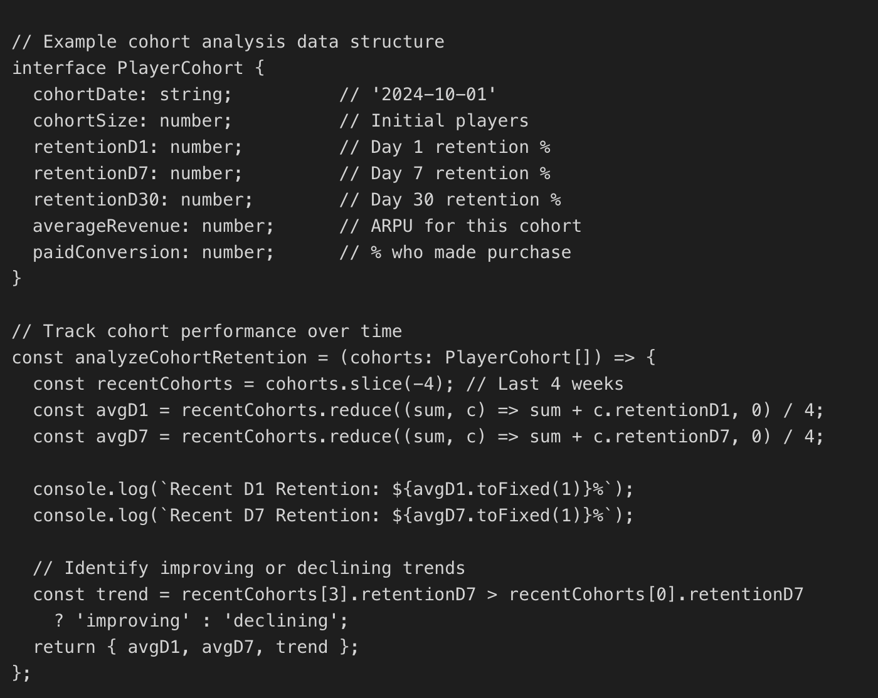
Player Segmentation Strategies
Effective player segmentation divides your audience into meaningful groups based on behavior, demographics, or value. The most common segmentation models in game analytics include RFM (Recency, Frequency, Monetary), player lifecycle stages (new, active, at-risk, churned), and behavioral archetypes (whales, grinders, casuals, socializers). Each segment requires different engagement strategies, content prioritization, and monetization approaches.
玩家分层运营策略
合理的玩家分层，是根据玩家行为、属性、付费能力划分群体。游戏数据分析领域主流分层模型包括：RFM 模型（最近活跃度、游玩频率、付费金额）、玩家生命周期分层（新玩家、活跃玩家、流失预警玩家、已流失玩家）、行为画像分层（高付费玩家、肝度玩家、休闲玩家、社交玩家）。不同分层需搭配差异化的运营策略、内容优先级与变现方案。
Segment | Definition | Engagement Strategy | Monetization Focus
Whales (Top 1%) | High spenders, $100+ monthly | VIP events, exclusive content, personalized offers | Premium bundles, limited editions
Dolphins (Top 10%) | Regular spenders, $10-100 monthly | Battle passes, seasonal content | Subscription models, value packs
Minnows | Occasional spenders, <$10 monthly | Limited-time sales, starter packs | Low-friction $0.99-$4.99 offers
Non-payers | Never purchased, engaged players | Rewarded ads, social features | Conversion campaigns, starter offers
At-Risk Players | Declining engagement, 3+ days inactive | Re-engagement notifications, comeback rewards | Win-back offers, bonus currency
玩家分层 | 定义 | 运营策略 | 变现方向
顶级付费玩家（前 1%） | 高付费群体，月消费 100 美元以上 | 专属 VIP 活动、限定内容、个性化福利 | 高端礼包、限量道具
中度付费玩家（前 10%） | 稳定付费群体，月消费 10-100 美元 | 战令、赛季专属内容 | 订阅服务、性价比礼包
轻度付费玩家 | 偶尔付费，月消费低于 10 美元 | 限时折扣、新手入门礼包 | 低价道具（0.99-4.99 美元档位）
零付费活跃玩家 | 从未付费，但保持活跃 | 激励式广告、社交玩法 | 付费转化活动、入门优惠
流失预警玩家 | 活跃度持续下降，连续 3 天以上未登录 | 召回推送、回归福利 | 回归专属优惠、游戏代币奖励
Advanced segmentation combines multiple behavioral signals to create hyper-targeted player groups. For example, "high-skill non-payers who play socially" might respond well to competitive cosmetic items, while "low-skill whales struggling with progression" need power-up offers. This level of segmentation requires sophisticated analytics platforms and dedicated data science resources but can dramatically improve both player satisfaction and monetization efficiency.
高阶分层会结合多重行为标签，打造精细化玩家群体。例如 “技术出色、零付费、偏爱社交玩法” 的玩家，更愿意为竞技类外观道具消费；而 “技术偏弱、高付费、卡关卡进度” 的玩家，更容易接受战力提升类道具。这类精细化运营需要成熟的数据分析平台与数据团队支撑，但能大幅提升玩家满意度与变现效率。
A/B Testing in Games: Framework & Best Practices
A/B testing enables data-driven decision-making by comparing different versions of game features, UI elements, or monetization strategies with statistically significant player samples. Unlike traditional development where changes ship to all players simultaneously, A/B testing reduces risk by validating hypotheses with small groups before full rollout. This approach has become standard practice in live service games where continuous optimization directly impacts revenue and retention.
A/B Testing Framework for Games
Step-by-Step Testing Process
- Hypothesis Formation: Define what you're testing and expected outcome (e.g., "Reducing tutorial length from 5 to 3 minutes will increase D1 retention by 5%")
- Success Metrics: Identify primary metric (D1 retention) and secondary metrics (tutorial completion, first session length)
- Sample Size Calculation: Use statistical power calculators to determine minimum sample size for significance (typically 5,000+ players per variant)
- Randomization: Randomly assign new players to control or test groups, ensuring no bias in distribution
- Test Duration: Run test long enough to capture full player lifecycle (minimum 7 days for retention tests, 14 days for monetization)
- Statistical Analysis: Calculate statistical significance (p-value < 0.05) and confidence intervals before making decisions
- Implementation: Roll winning variant to 100% of players or run follow-up tests to optimize further
Reward & Monetization A/B Testing
For reward or monetization experiments:
Primary Metrics:
- Payer Conversion Rate
- ARPU (Average Revenue Per User)
- ARPPU (Average Revenue Per Paying User)
- Revenue Per User
- Repeat Purchase Rate
- D7 Retention

Secondary Metrics:
- Session Duration
- Reward Claim Rate
- Item Usage Rate
- Churn Rate
- Feature Adoption Rate

Example:
Hypothesis:
Giving recharge credits will increase payer conversion rate by 10% compared with free in-game items.

Primary Metric:
Payer Conversion Rate

Secondary Metrics:
ARPPU, D7 Retention, Session Duration
五、游戏 A/B 测试：执行框架与最佳实践
A/B 测试依托统计学原理，将功能、界面、变现方案等内容分为不同版本，投放给样本量充足的玩家群体进行对比，用数据支撑决策。传统模式下，版本会全量推送给所有玩家；而 A/B 测试可先小范围验证方案效果，再全面上线，降低试错风险。目前该方式已成为长线运营游戏的标准流程，直接影响留存与收益表现。
游戏 A/B 测试完整流程
- 提出假设：明确测试内容与预期效果（例：将教程时长从 5 分钟缩短至 3 分钟，预计次日留存提升 5%）。
- 确定核心指标：锁定主指标（如次日留存）与辅助指标（教程完成率、首次游玩时长）。
- 计算样本量：借助统计工具测算最小样本数，保证结果具备统计学意义（单版本建议至少 5000 名玩家）。
- 随机分组：将新玩家随机分配至对照组、测试组，保证分组无偏差。
- 设定测试周期：测试时长需覆盖玩家完整行为周期；留存测试最少 7 天，变现测试建议 14 天以上。
- 统计分析：计算显著性（P 值＜0.05 为有效）与置信区间，再判定方案优劣。
- 落地执行：将最优版本全量上线，或针对测试结果开展新一轮优化测试。
Common Game A/B Test Scenarios
Different aspects of game design benefit from A/B testing at different stages of development and live operations. Onboarding tests should run continuously as you iterate on first-time user experience, while economy tests require careful monitoring to avoid exploits or player frustration. The following scenarios represent high-impact test opportunities that consistently improve game performance.
- Onboarding Optimization: Test tutorial length, skip options, reward timing, and complexity—even 5% retention improvements compound significantly
- Pricing Psychology: Compare $4.99 vs $5.00, bundle sizes, discount percentages, and limited-time pressure tactics
- Feature Discovery: Test different UI placements for new features, tutorial prompts, and notification strategies to maximize adoption
- Difficulty Balancing: Validate progression curves by testing different difficulty settings and measuring player advancement & satisfaction
- Reward Structures: Compare daily login bonuses, achievement rewards, and progression incentives to optimize engagement loops
- Social Features: Test friend invite incentives, social sharing prompts, and multiplayer matchmaking algorithms

游戏常见 A/B 测试场景
游戏研发与线上运营的多个环节都适合开展 A/B 测试，其中高性价比场景如下：
- 新手引导优化：测试教程时长、跳过功能、奖励发放时机与难度，留存小幅提升也会带来长期复利。
- 定价策略测试：对比不同定价（4.99 美元与 5.00 美元）、礼包规格、折扣力度、限时营销玩法。
- 功能曝光测试：调整新功能界面位置、教程引导、推送方式，提升功能使用率。
- 难度平衡测试：调整关卡难度曲线，观察玩家闯关数据与满意度变化。
- 奖励体系测试：对比每日登录奖励、成就奖励、闯关激励，优化游玩循环。
- 社交功能测试：测试好友邀请福利、社交分享引导、多人匹配算法。

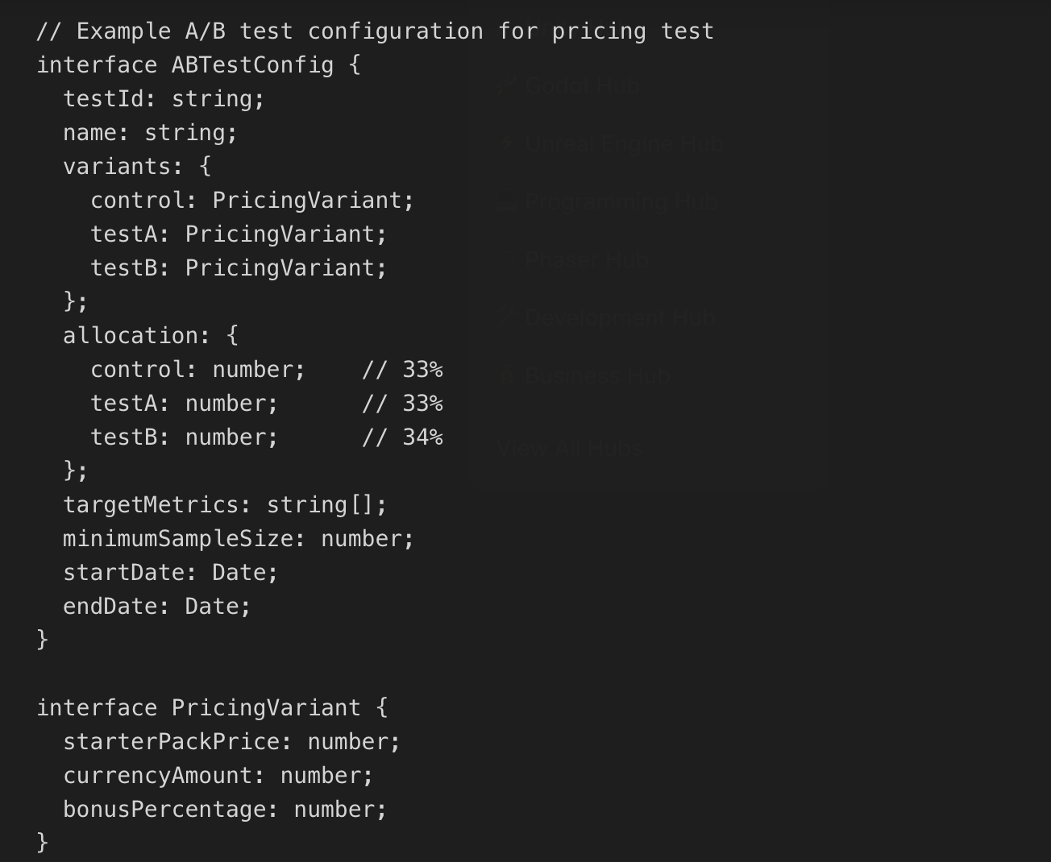
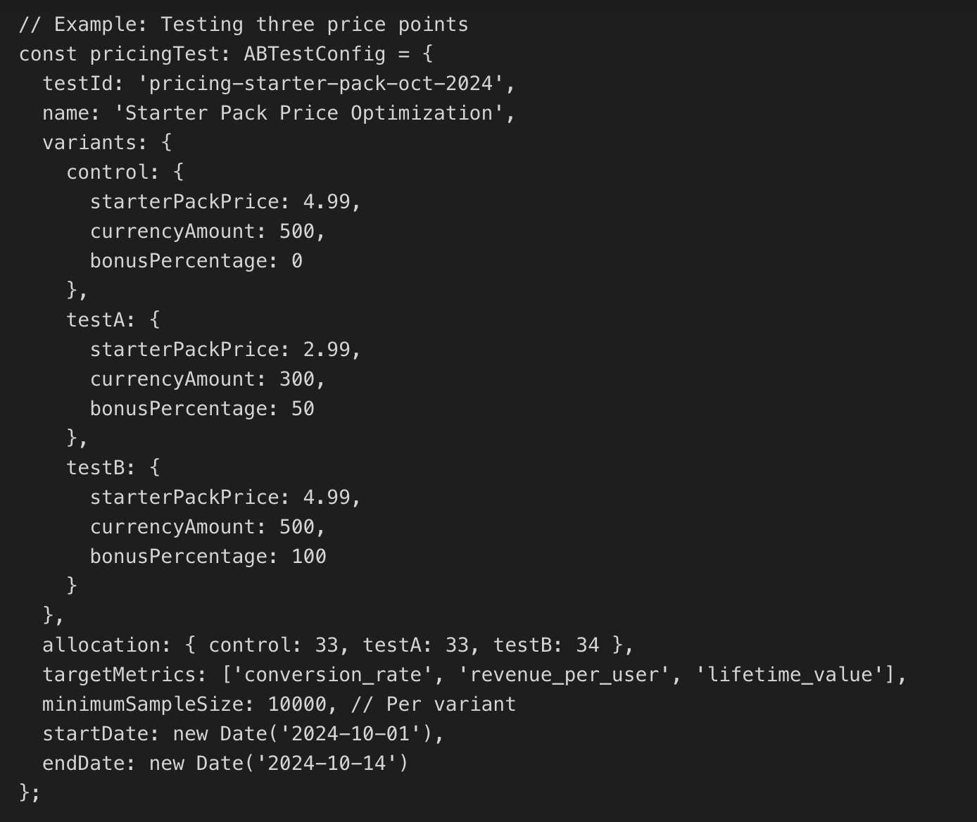
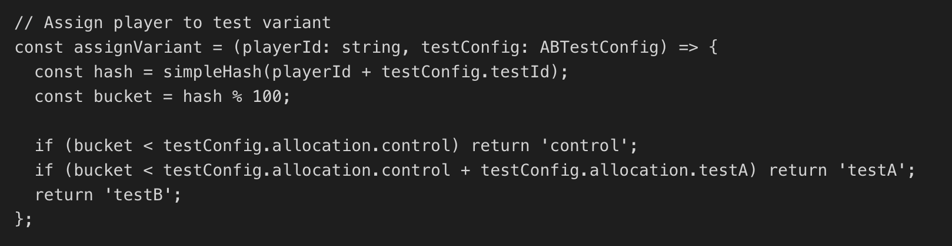
A/B Testing Pitfalls to Avoid
- Insufficient Sample Size: Testing with too few players leads to false positives—always calculate required sample size before launching
- Short Test Duration: Ending tests too early misses long-term effects—retention tests need 14+ days, monetization tests need 30+ days
- Multiple Concurrent Tests: Running overlapping tests on same player population creates interaction effects and invalidates results
- Ignoring Segmentation: Changes might work for one player segment but hurt another—analyze results by cohort and behavior
- Novelty Effect: Initial excitement about new features fades—measure sustained impact, not just week-one spikes
- P-hacking: Cherry-picking metrics that show positive results while ignoring negative impacts on other KPIs

A/B 测试常见误区（需规避）
- 样本量不足：测试玩家过少，易得出错误结论，上线前务必核算样本规模。
- 测试周期过短：无法观测长期效果；留存测试建议 14 天以上，变现测试建议 30 天以上。
- 同批次叠加多个测试：同一批玩家同时参与多项测试，会互相干扰，导致数据失效。
- 忽略玩家分层：部分方案对某类玩家有效，却会损害另一类玩家体验，需按群组拆分分析数据。
- 新鲜感效应：新功能上线初期热度较高，热度回落之后效果可能反转，需观测长期数据。
- 数据刻意筛选：只挑选利好指标，刻意忽略负面数据。
Monetization Analytics: Revenue Tracking & Optimization
Monetization analytics focuses on understanding how players convert to payers, what drives spending behavior, and how to optimize lifetime value while maintaining player satisfaction. For free-to-play games, monetization represents the primary business metric, but even premium titles benefit from tracking DLC performance, season pass adoption, and cosmetic sales. This section covers essential revenue metrics, analysis frameworks, and optimization strategies used by top-performing games.
六、变现数据分析：收益统计与优化
变现数据分析主要研究玩家付费转化逻辑、消费行为驱动因素，在保证玩家体验的前提下，提升玩家终身价值。对于免费游戏，变现是核心商业指标；即便买断制付费游戏，也需要统计后续可下载内容（DLC）、赛季通行证、外观道具的销售数据。本章节介绍变现核心指标、分析框架与主流优化方案。
Core Monetization Metrics 变现核心指标
Metric | Formula | Purpose | Industry Benchmark
ARPU (Average Revenue Per User) | Total Revenue / Total Users | Overall monetization efficiency across entire player base | Mobile: $0.10-$1.00/user
ARPPU (Average Revenue Per Paying User) | Total Revenue / Paying Users | How much payers spend on average | Mobile: $5-$25/payer
ARPDAU (Average Revenue Per Daily Active User) | Daily Revenue / DAU | Daily monetization efficiency, engagement quality | Mobile: $0.05-$0.50/DAU
Conversion Rate | Paying Users / Total Users × 100 | Percentage of players who make any purchase | Mobile: 1-5%, PC: 3-10%
LTV (Lifetime Value) | ARPU × Average Lifetime (days) | Total revenue expected from average player | Mobile: $0.50-$5.00
Payer LTV | ARPPU × Average Payer Lifetime | Total revenue from paying players only | Mobile: $20-$200+
Time to First Purchase | Days from install to first IAP | Conversion velocity and onboarding effectiveness | Mobile: 2-7 days median
指标名称 | 计算公式 | 作用 | 行业参考标准
每用户平均收入（ARPU） | 总收入 ÷ 总玩家数 | 衡量全体玩家的整体变现效率 | 移动端：单用户 0.10-1.00 美元
每付费用户平均收入（ARPPU） | 总收入 ÷ 付费玩家数 | 统计付费玩家的人均消费金额 | 移动端：单付费用户 5-25 美元
每日活用户平均收入（ARPDAU） | 单日总收入 ÷ 当日活跃用户数 | 评估每日变现效率与活跃度质量 | 移动端：单日活用户 0.05-0.50 美元
付费转化率 | （付费玩家数 ÷ 总玩家数）×100% | 玩家产生付费行为的比例 | 移动端：1%-5%；电脑端：3%-10%
玩家终身价值（LTV） | 每用户平均收入 × 玩家平均游玩天数 | 预估单个玩家全生命周期贡献收益 | 移动端：0.50-5.00 美元
付费玩家终身价值 | 每付费用户平均收入 × 付费玩家平均游玩天数 | 仅统计付费玩家的全生命周期收益 | 移动端：20-200 美元及以上
首次付费间隔 | 玩家下载游戏到首次内购的天数 | 衡量付费转化速度与新手引导效果 | 移动端：中位数 2-7 天

Revenue Funnel Analysis
Understanding your monetization funnel reveals exactly where players drop off in the purchase journey. Top-performing games optimize each step—from first store visit through payment confirmation—to minimize friction and maximize conversion. Even small improvements at each stage compound into significant revenue increases.
变现漏斗分析
分析变现漏斗，能清晰定位玩家在付费流程中的流失节点。优质游戏会优化从首次进入商城到完成付款的每一个环节，减少操作阻碍、提升转化率。单一步骤的小幅优化，叠加后会带来可观的收益增长。
Example Monetization Funnel
Total Active Players (30 days)100,000 players (100%)
Visited In-Game Store45,000 players (45%) - Good discovery
Clicked on Offer18,000 players (40% of visitors, 18% overall) - Offer appeal issue?
Initiated Purchase9,000 players (50% of clickers, 9% overall) - Good intent
Completed Purchase7,200 players (80% completion, 7.2% overall conversion) - 20% payment drop-off
Key Insights: The 20% drop-off at payment indicates payment friction (too many steps, unclear pricing, or payment method issues). Priority: streamline checkout flow and add more payment options.
示例：30 天变现漏斗
- 总活跃玩家：10 万人（100%）
- 进入游戏商城：4.5 万人（45%），商城曝光效果良好
- 点击商品：1.8 万人（商城访客的 40%，总人数 18%），商品吸引力存在优化空间
- 发起支付：9000 人（点击商品用户的 50%，总人数 9%），玩家付费意愿充足
- 完成付款：7200 人（发起支付用户的 80%，整体转化率 7.2%），支付环节流失 20%
核心结论：支付环节 20% 的流失，说明付款流程繁琐、定价模糊或支付方式不足。优化优先级：简化结算流程，增加支付渠道。
Monetization Optimization Strategies
- First Purchase Optimization: The first purchase is psychological breakthrough—offer compelling starter packs at $0.99-$2.99 to convert hesitant players
- Segmented Offers: Show different offers to whales vs minnows—high spenders see premium bundles, new players see starter packs
- Time-Limited Pressure: Limited-time offers increase urgency but overuse causes fatigue—balance exclusivity with availability
- Value Perception: Show "bonus" currency clearly—"500 + 500 BONUS" converts better than "1000 gems"
- Price Anchoring: Display higher-priced options first to make mid-tier offers seem more reasonable
- Progression Gates: Strategic difficulty spikes drive purchases, but must feel fair—balance challenge with player agency

变现优化策略
- 优化首次付费：首次付费是玩家心态的重要转折点，推出低价入门礼包（0.99-2.99 美元），撬动犹豫玩家转化。
- 分层推送商品：向高付费玩家展示高端礼包，向新玩家推送入门礼包，做到千人千面。
- 限时营销：利用限时活动营造稀缺感，但过度使用会让玩家产生审美疲劳，需把控节奏。
- 强化价值感知：标注 “额外赠送代币”（如 500 代币 + 额外赠送 500），比直接标注 “1000 代币” 转化效果更好。
- 价格锚定：优先展示高价商品，让中档商品显得性价比更高。
- 合理设置进度卡点：适度提升关卡难度可引导付费，但需保证公平性，避免玩家反感。
For comprehensive monetization strategy development including pricing psychology, IAP design, and revenue forecasting, read our complete guide on mobile game monetization strategies which covers proven frameworks used by top-grossing games.
Implementing Game Analytics: Events, Custom Metrics & Integration
Successful analytics implementation requires careful planning around event taxonomy, integration architecture, and data quality standards. Rushing implementation leads to fragmented data, inconsistent naming conventions, and difficulty extracting insights. This section provides a framework for implementing analytics properly from day one, whether you're building a new game or retrofitting analytics into an existing project.
七、游戏数据分析落地：事件、自定义指标与接入部署
搭建数据分析体系，需提前规划事件分类、命名规则、架构逻辑，保证数据质量。仓促上线会导致数据杂乱、命名不统一，后续难以分析。本章节讲解从零搭建数据分析体系的完整方案，适用于新游戏开发或老游戏改造。
Event Taxonomy & Naming Conventions
Consistent event naming enables easier analysis and prevents data fragmentation as your game grows. Establish conventions early—such as object-action naming ("level_complete", "item_purchase") or action-object ("complete_level", "purchase_item")—and document them for your entire team. Include critical context in event parameters rather than creating hundreds of unique event names.
事件分类与命名规范
统一的事件命名规则，能降低后期分析难度，避免数据碎片化。团队需提前制定规范，例如采用 **“对象 - 动作”（关卡 - 完成）或“动作 - 对象”（完成 - 关卡）** 格式，并全员执行。尽量在事件参数中补充详细信息，而非创建大量零散事件名称。

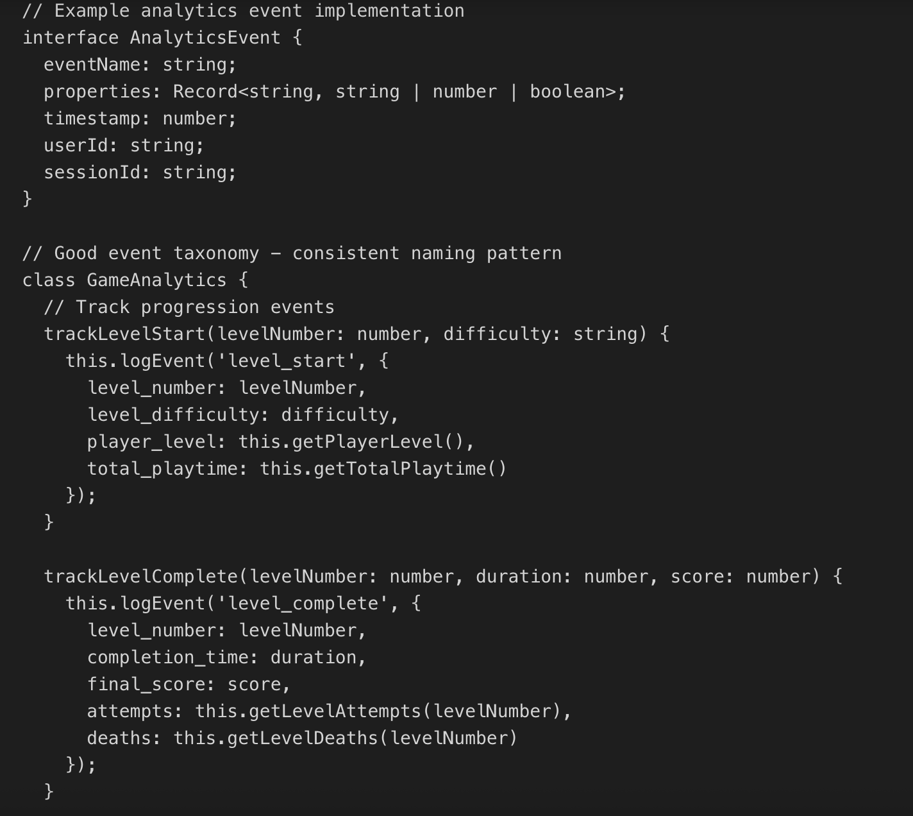
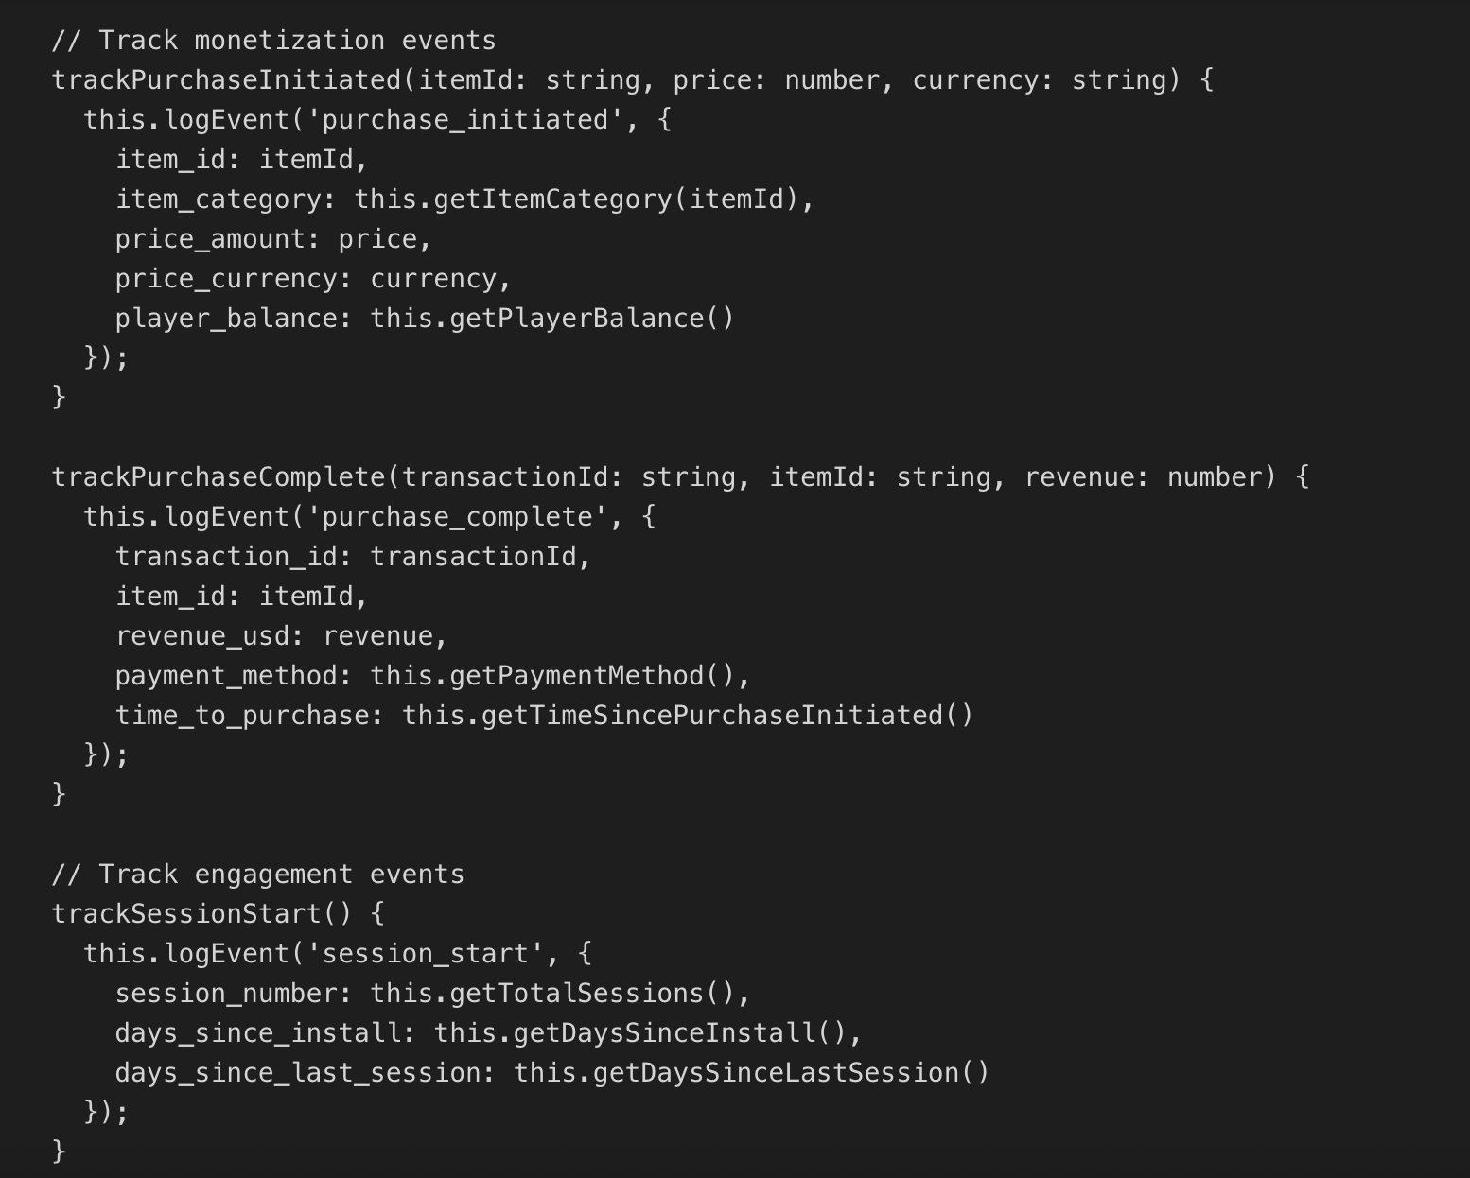
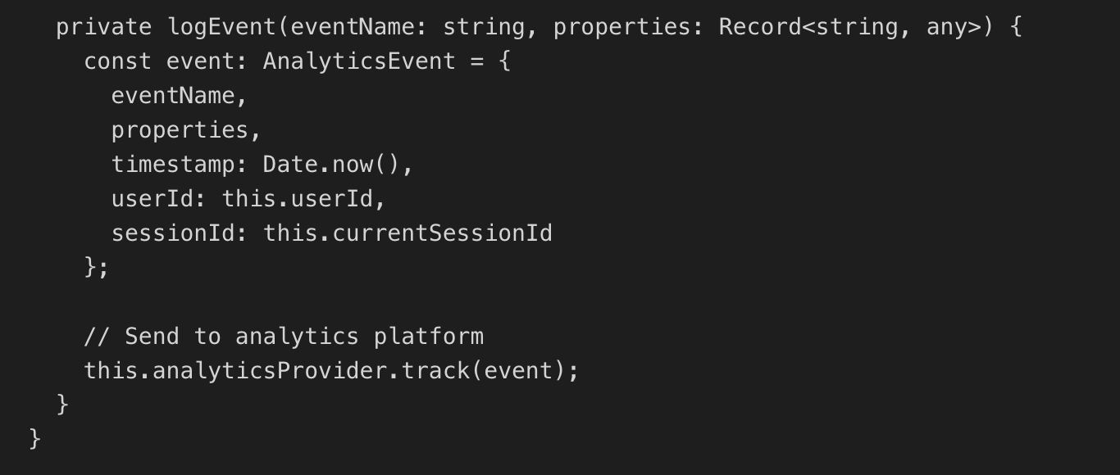
Essential Event Categories 核心事件分类
Category | Example Events | Critical Parameters
Lifecycle | app_install, session_start, session_end, app_uninstall | install_source, session_duration, total_sessions
Progression | level_start, level_complete, level_fail, achievement_unlock | level_number, completion_time, attempts, score
Monetization | purchase_initiated, purchase_complete, purchase_failed, ad_watched | item_id, price, currency, transaction_id, revenue
Economy | currency_earned, currency_spent, item_acquired, item_used | currency_type, amount, source, item_category
Social | friend_invite, message_sent, guild_join, pvp_match | recipient_id, message_type, guild_id, match_result
Errors | error_occurred, crash_detected, connection_lost, timeout | error_code, error_message, stack_trace, device_info
分类 | 典型事件 | 必备参数
玩家生命周期 | 游戏安装、会话开启、会话结束、游戏卸载 | 获客渠道、单次游玩时长、总游玩次数
关卡进度 | 开启关卡、通关关卡、闯关失败、解锁成就 | 关卡编号、通关时长、尝试次数、得分
付费变现 | 发起支付、完成支付、支付失败、观看广告 | 商品 ID、价格、币种、交易单号、收益金额
游戏经济 | 代币获取、代币消耗、道具获取、道具使用 | 代币类型、数量、获取渠道、道具分类
社交玩法 | 邀请好友、发送消息、加入公会、对战对局 | 接收方 ID、消息类型、公会 ID、对局结果
异常报错 | 程序报错、游戏崩溃、网络中断、连接超时 | 错误代码、报错信息、日志、设备信息

Analytics Integration Best Practices
- Batch Event Sending: Queue events locally and send in batches to reduce network overhead and improve game performance
- Offline Support: Store events when offline and sync when connection returns—don't lose data due to connectivity issues
- Error Handling: Wrap analytics calls in try-catch blocks—analytics failures should never crash your game
- Performance Impact: Profile analytics overhead—if it affects frame rate, optimize batching or use background threads
- Testing & Validation: Use debug modes to verify events fire correctly before production deployment
- Documentation: Maintain an event specification document listing all events, parameters, and when they fire
数据分析接入最佳实践
- 批量上报事件：本地暂存数据，批量上传，减少网络消耗，避免影响游戏运行。
- 离线数据缓存：断网时本地保存事件，恢复网络后自动同步，防止数据丢失。
- 异常捕获：将数据上报代码嵌入异常捕获逻辑，数据分析故障不得导致游戏闪退。
- 控制性能损耗：监测数据上报对游戏帧率的影响，必要时优化批量规则、启用后台线程。
- 测试验证：正式上线前，通过调试模式校验所有事件是否正常触发。
- 文档留存：整理事件说明文档，标注每类事件、参数、触发场景。
Data-Driven Game Design: Using Analytics to Improve Games
Data-driven game design uses player behavior analytics to inform design decisions, validate hypotheses, and identify improvement opportunities. Rather than replacing designer intuition, analytics provides objective evidence to support or challenge assumptions about player experience. The most successful games combine creative vision with data insights to create experiences that resonate with their target audience while achieving business goals.
八、数据驱动型游戏设计：用数据分析优化产品
数据驱动设计，并非取代设计师的创意，而是用客观数据验证设计思路、挖掘优化方向。顶尖游戏团队会结合创意理念与数据洞察，打造贴合玩家喜好、商业表现优异的产品。
Identifying Design Problems Through Data
Analytics reveals design problems that playtesting might miss, especially issues that emerge over time or affect small player segments. By tracking player behavior at scale, you can identify friction points, confusing mechanics, difficulty spikes, and underutilized features that need designer attention. The key is knowing which metrics indicate specific design issues.
Common Data Signals & Design Implications
- High Drop-off at Specific Level: Indicates difficulty spike or confusing mechanic introduction—needs rebalancing or better tutorial
- Low Feature Adoption (<20% of players): Feature is poorly communicated, difficult to discover, or doesn't provide clear value
- Decreasing Session Length Over Time: Core gameplay loop loses appeal—needs content variety or meta-game depth
- Currency Hoarding (High Balance, Low Spending): Nothing worth buying or unclear value—economy needs rebalancing
- Sudden Retention Drop After Update: New feature or balance change negatively impacted experience—needs investigation and potential rollback
- Low Match Completion in Multiplayer: Matches too long, poor matchmaking creating unfair games, or connection issues

从数据中识别设计问题
数据分析能发现线下试玩难以察觉的问题（长期积累问题、小众玩家群体问题）。通过海量玩家行为数据，定位操作卡点、晦涩玩法、难度突变、冷门功能等问题。常见数据信号与对应问题如下：
- 某一关卡流失率高：关卡难度突增，或新玩法讲解不到位，需平衡难度、补充引导。
- 功能使用率低于 20%：功能曝光不足、玩家难以发现，或玩法价值偏低。
- 单次游玩时长持续下降：核心玩法新鲜感流失，需补充新内容或拓展衍生玩法。
- 玩家囤积代币、极少消耗：游戏内没有值得消费的道具，经济体系需要调整。
- 版本更新后留存骤降：新功能或数值改动破坏了玩家体验，需排查问题、考虑回滚。
- 多人对局完成率低：对局时长过长、匹配机制不公平，或存在网络问题。
Balancing Difficulty Curves with Data
Difficulty balancing represents one of the most impactful areas where analytics guides design. By tracking completion rates, attempt counts, and time-to-complete across all levels or challenges, designers can identify progression bottlenecks and optimize difficulty curves for broader appeal. The goal is maintaining challenge without frustration, which varies significantly across player skill levels.

基于数据优化难度曲线
数值与难度平衡是数据分析的核心应用场景。统计所有关卡的通关率、尝试次数、通关时长，可精准找到进度卡点，优化难度曲线，兼顾不同水平玩家的体验。优化目标：保证游戏有挑战性，同时不让玩家产生挫败感。
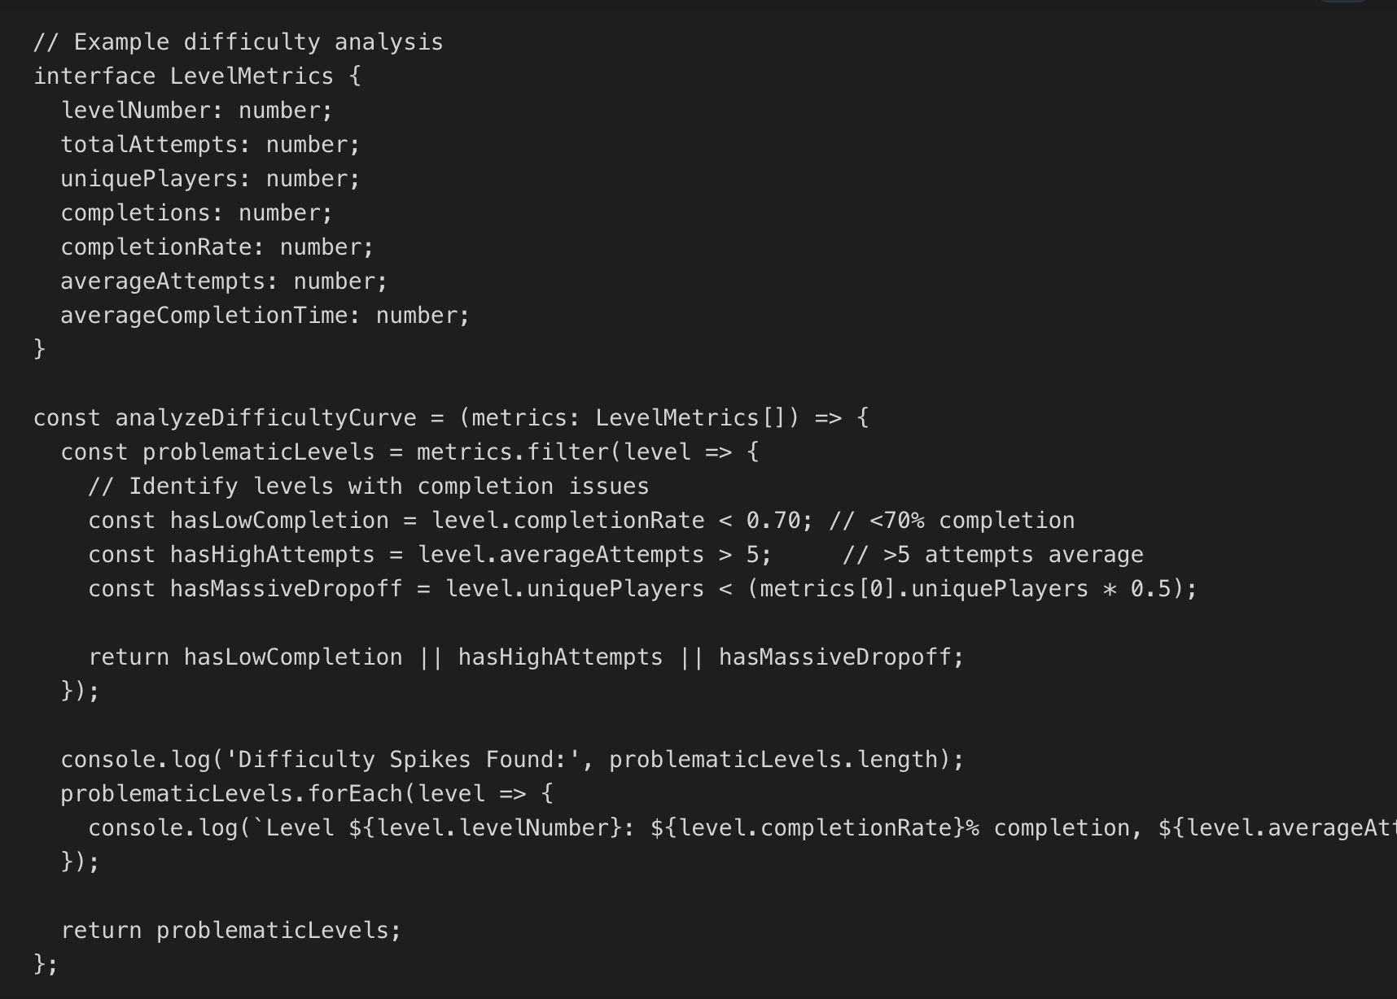
截图不完整的一行补充：console.log(`Level ${level.levelNumber}: ${level.completionRate}% completion, ${level.averageAttempts} avg attempts`);
});
Optimizing Onboarding with Analytics
Onboarding quality directly impacts D1 retention, making it one of the highest-leverage areas for data-driven optimization. Track tutorial completion rates, time-to-complete each step, and first-session actions to understand where new players struggle. The best onboarding experiences use analytics to continuously refine the new user experience, testing different tutorial lengths, reward timing, and complexity introduction.
- Tutorial Length Optimization: Measure correlation between tutorial completion and D1 retention—longer isn't always better
- Early Wins: Players who experience success in first session have higher retention—ensure tutorial creates achievable victories
- Feature Introduction Pacing: Track when players naturally discover features vs when tutorials force-teach them
- Skip Options: Offer skip for returning players or those who demonstrate competence—forced tutorials frustrate experienced gamers

借助数据分析优化新手引导
新手引导直接决定次日留存，是投入产出比最高的优化方向。统计教程完成率、单步耗时、首次游玩行为，定位新手卡点。优化要点：
- 教程时长优化：结合教程完成率与次日留存数据，找到最优教程长度，并非越长效果越好。
- 快速获得正向反馈：让玩家在首次游玩中快速体验成就感，提升留存意愿。
- 分阶段讲解功能：顺应玩家自然探索节奏，而非强行灌输所有玩法。
- 教程跳过功能：为回归玩家、熟练玩家提供跳过选项，强制教程易引发反感。
Privacy & GDPR Compliance for Game Analytics
Privacy regulations like GDPR (Europe), CCPA (California), and COPPA (children's data) impose strict requirements on how games collect, store, and use player data. Non-compliance risks significant fines and platform removal, making privacy compliance essential for any game collecting analytics data. This section covers key requirements, implementation strategies, and best practices for privacy-compliant analytics.
九、数据分析隐私合规：适配 GDPR 等法规
欧盟《通用数据保护条例》（GDPR）、美国《加州消费者隐私法》（CCPA）、《儿童在线隐私保护法》（COPPA）等法规，对游戏数据采集、存储、使用做出严格要求。违规将面临高额罚款、平台下架风险，合规是数据采集的基本前提。
GDPR Requirements for Game Analytics
- Consent Requirements: Must obtain explicit opt-in consent before collecting personal data—pre-checked boxes don't qualify
- Data Minimization: Only collect data necessary for stated purposes—avoid "collect everything" approaches
- Right to Access: Players can request all data you've collected about them—implement data export functionality
- Right to Deletion: Players can request complete data deletion—implement account deletion with data purge
- Data Portability: Players can request data in machine-readable format for transfer to competitors
- Breach Notification: Must notify users and authorities within 72 hours of data breaches affecting personal information

GDPR 合规要求（欧盟）
- 授权同意：采集个人数据前，必须获得玩家主动勾选同意，预设勾选视为无效。
- 数据最小化：仅采集业务必需的数据，禁止无差别采集所有信息。
- 数据查询权：玩家可申请调取平台存储的个人数据，游戏需提供数据导出功能。
- 数据删除权：玩家可申请彻底删除个人数据，游戏需完成账号与数据清除。
- 数据可迁移权：玩家可申请将个人数据导出为通用格式，转移至其他平台。
- 安全事件上报：发生数据泄露后，需在 72 小时内通知用户与监管机构。
Privacy-First Analytics Implementation
Privacy-compliant analytics balances data collection needs with user privacy rights. Best practices include anonymizing data where possible, using consent management platforms, implementing data retention policies, and providing transparent privacy policies. Many analytics platforms now offer GDPR-compliant modes that automatically handle consent and data deletion requests.
隐私优先型数据采集方案
平衡数据分析需求与用户隐私，主流做法：对数据做匿名化处理、使用授权管理工具、制定数据留存规则、公示隐私政策。目前多数数据分析平台已上线 GDPR 合规模式，自动处理授权与删号需求。

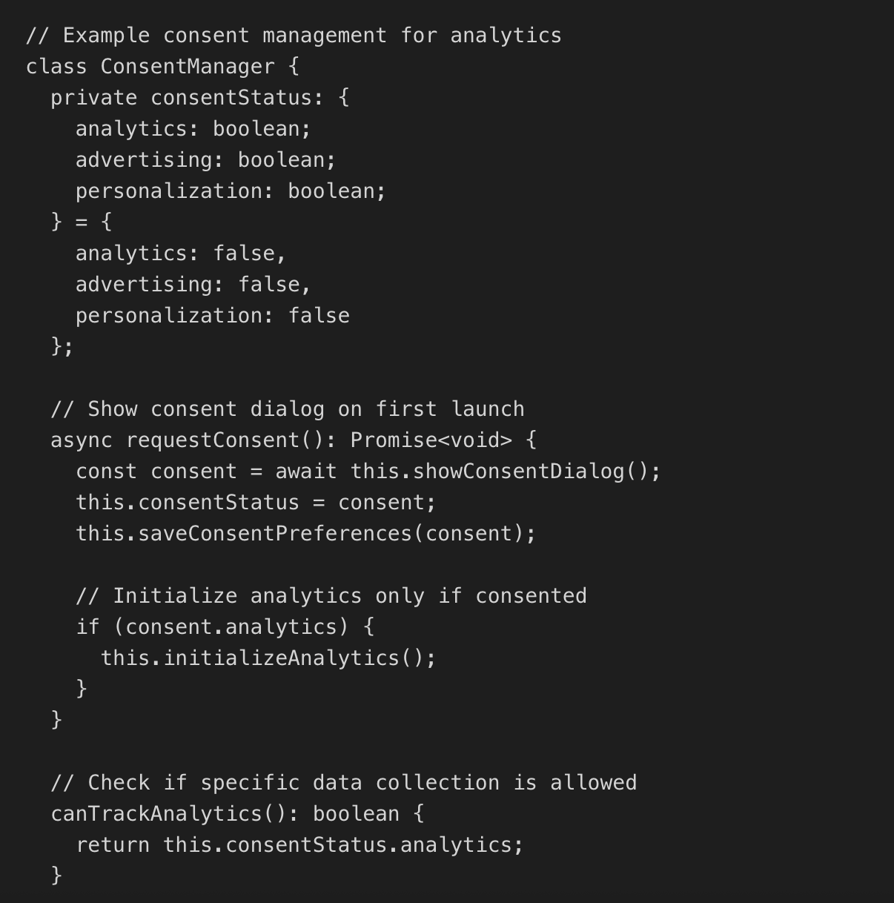
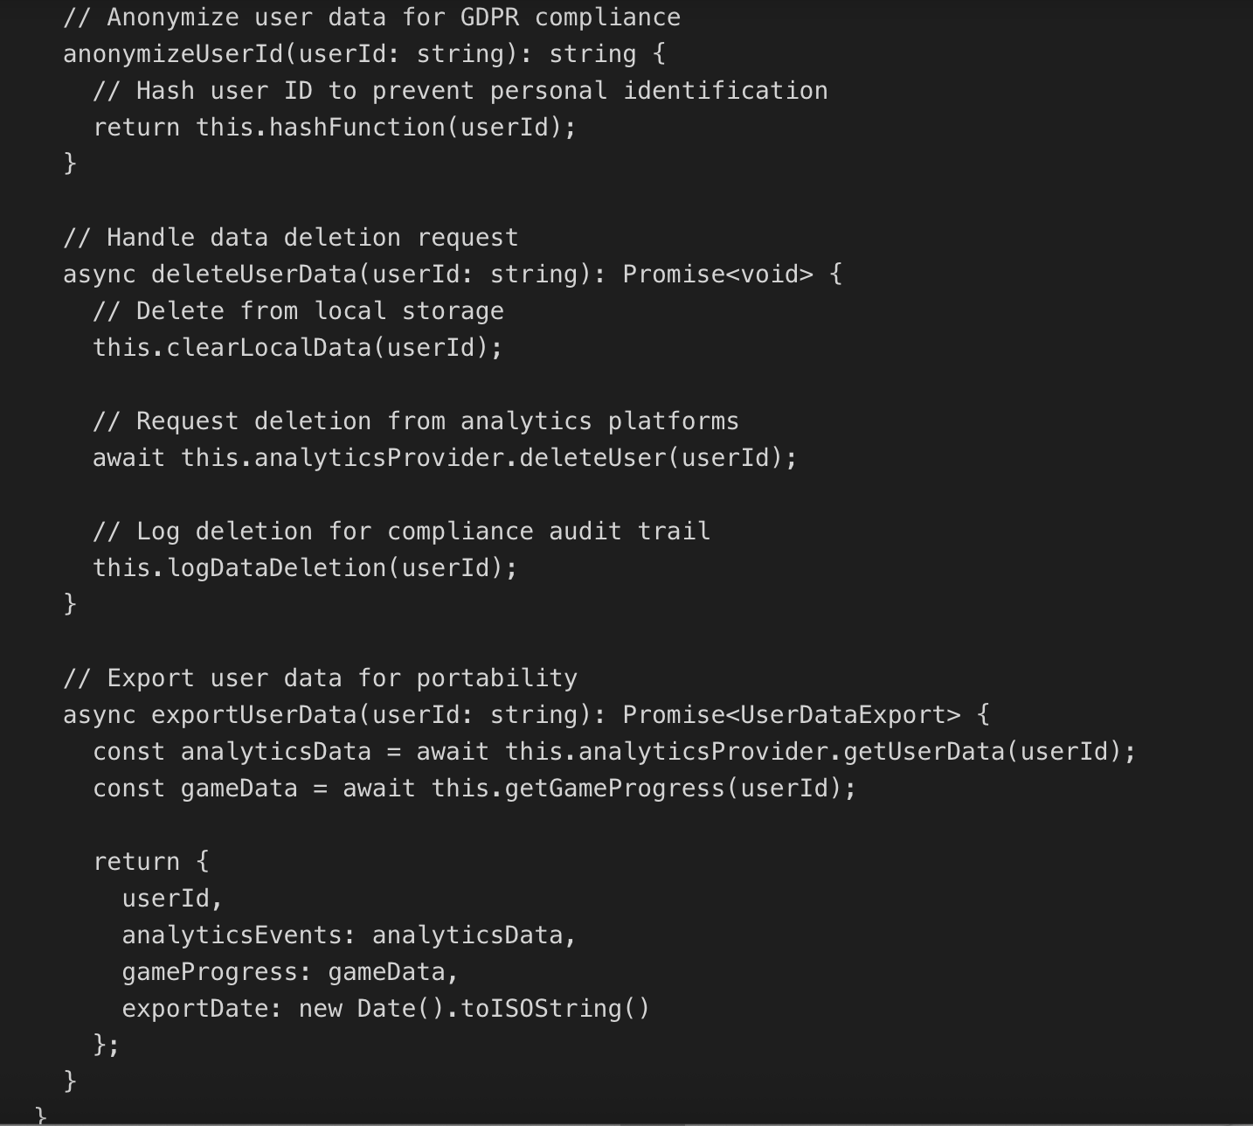
COPPA Compliance for Kids' Games
Games targeting children under 13 must comply with COPPA (Children's Online Privacy Protection Act), which prohibits collecting personal information from children without parental consent. This includes email addresses, location data, photos, and even persistent identifiers in some contexts. Many studios avoid COPPA compliance complexity by restricting games to ages 13+ or implementing strict "kids mode" that disables all data collection.
- Age Gates: Implement age verification before allowing account creation or data collection
- Anonymous Analytics: Use device-based anonymous identifiers that can't be linked to individual children
- No Behavioral Advertising: COPPA prohibits targeted advertising to children based on behavioral data
- Parental Controls: Provide parents ability to review, delete, and control child's data

面向儿童的 COPPA 合规要求
面向 13 岁以下儿童的游戏，必须遵守《儿童在线隐私保护法》：未经监护人许可，禁止采集邮箱、位置、照片等个人信息。多数工作室会选择限制游戏适龄（13 岁以上），或开启儿童专属模式、关闭全部数据采集功能。
- 年龄校验：账号注册、数据采集前，增加年龄验证环节。
- 匿名数据统计：使用设备匿名标识，无法关联到具体儿童个人。
- 禁止行为广告：不基于儿童行为推送定向广告。
- 家长管控功能：支持家长查看、删除、管理儿童数据。
Analytics Career in Games: Roles & Career Path
The growing importance of data-driven game development has created strong demand for analytics specialists in the games industry. Careers range from entry-level data analysts to senior positions like Director of Analytics or VP of Data Science. Game analytics roles combine technical skills (SQL, Python, statistics) with game industry knowledge and business acumen, making them excellent career paths for data-minded individuals passionate about games.
Frequently Asked Questions 常见问题解答
What is game analytics?
Game analytics is the systematic collection, measurement, and analysis of player behavior data to optimize game design, improve retention, and maximize revenue. It involves tracking metrics like daily active users, retention rates, session length, and monetization performance to make data-driven decisions about game development and live operations rather than relying solely on intuition or limited playtesting feedback.
什么是游戏数据分析？
游戏数据分析是系统性采集、统计、分析玩家行为数据，以此优化玩法、提升留存、增加收益。核心追踪日活、留存、游玩时长、变现等指标，用数据辅助研发与运营决策，而非单纯依靠主观经验。
What metrics should I track in my game?
Essential metrics include DAU (Daily Active Users), retention rates (D1, D7, D30), session length, sessions per day, and for monetized games, ARPU (Average Revenue Per User), conversion rate, and LTV (Lifetime Value). Start with these universal metrics, then add genre-specific KPIs like completion rates for puzzle games, kill/death ratios for shooters, or guild participation for MMOs. Focus on actionable metrics that inform specific design or business decisions.
游戏需要追踪哪些指标？
基础必看指标：日活、次日 / 七日 / 三十日留存、单次游玩时长、每日游玩次数；商业化游戏额外关注：每用户平均收入、付费转化率、玩家终身价值。在此基础上，结合品类补充专属指标（益智游戏看通关率、射击游戏看击杀死亡比、大型多人在线游戏看公会活跃度）。优先选择能指导优化的落地型指标。
What is good retention for a mobile game?
Industry benchmarks for mobile games vary by genre, but generally D1 retention of 35-45%, D7 retention of 15-25%, and D30 retention of 5-10% indicate solid performance. Match-3 puzzle games typically achieve higher retention (40-50% D1) while hypercasual games see lower retention (25-35% D1) due to simpler gameplay loops. Premium PC games often achieve 60-75% D1 retention due to purchase commitment creating player investment.
手游优秀留存标准是什么？
不同品类标准不同：整体手游次日留存 35%-45%、七日留存 15%-25%、三十日留存 5%-10% 属于优质水平。三消益智类表现更高（次日 40%-50%）；超休闲游戏玩法简单，留存偏低（次日 25%-35%）。买断制电脑游戏因玩家付费门槛，次日留存可达 60%-75%。
How do I implement game analytics?
Start by selecting an analytics platform (GameAnalytics, Unity Analytics, or Firebase for mobile), integrate their SDK into your game engine, define your event taxonomy with consistent naming conventions, implement tracking for key player actions (sessions, progression, monetization), and create dashboards to monitor core KPIs. Begin with basic lifecycle and progression events, then add custom events as your needs mature. Always test analytics implementation before production release.
如何部署游戏数据分析？
先选定平台（独立开发者优先选 GameAnalytics、Unity 数据分析，移动端优先选谷歌火基）；接入官方 SDK；统一事件命名规则，部署玩家生命周期、关卡、付费等核心事件；搭建数据看板监控核心指标。优先上线基础事件，再逐步补充自定义事件，上线前完成全流程测试。
How long should I run an A/B test in my game?
A/B test duration depends on what you're testing and your player volume. Retention tests need minimum 7-14 days to capture weekly play patterns, while monetization tests should run 14-30 days to account for purchase timing variations. Ensure you achieve statistical significance (typically 5,000+ players per variant) before ending tests. Short-term metric improvements sometimes mask long-term negative effects, so favor longer test durations when possible.
A/B 测试需要运行多久？
测试时长取决于测试内容与玩家体量：留存类测试最少 7-14 天，覆盖完整周度游玩规律；变现类测试建议 14-30 天，适配玩家付费周期。单版本样本量建议不少于 5000 人，保证数据有效。短期利好不代表长期稳定，条件允许尽量延长测试周期。
What is the difference between ARPU and ARPPU?
ARPU (Average Revenue Per User) divides total revenue by all users, including non-payers, showing overall monetization efficiency across your entire player base. ARPPU (Average Revenue Per Paying User) divides total revenue by only paying users, revealing how much money payers actually spend. Use ARPU to measure overall business health and ARPPU to understand payer spending behavior. Combined with conversion rate, these metrics provide complete monetization picture.
ARPU 和 ARPPU 的区别？
ARPU（每用户平均收入）：总收入 ÷ 全体玩家，反映游戏整体变现能力，包含零付费玩家。
ARPPU（每付费用户平均收入）：总收入 ÷ 付费玩家，仅统计付费玩家的人均消费。
结合付费转化率、ARPU、ARPPU 三项指标，可完整评估游戏变现水平。
Do I need to comply with GDPR for my game?
Yes, if you have any players in the European Union, you must comply with GDPR regardless of where your studio is located. GDPR requires explicit consent before collecting personal data, providing data access and deletion capabilities, and implementing appropriate security measures. Most analytics platforms offer GDPR-compliant modes that handle consent and deletion requests automatically. Implement consent dialogs, privacy policies, and data deletion functionality from day one.
面向欧盟玩家，是否需要遵守 GDPR？
需要。无论工作室所在地，只要游戏有欧盟地区玩家，就必须合规。核心要求：数据采集前获取玩家主动同意、开放数据查询与删除功能、完善安全防护。主流数据分析平台均提供 GDPR 合规模式，建议游戏上线初期就配置授权弹窗与隐私政策。
How can analytics improve my game's retention?
Analytics improves retention by identifying exactly where and why players churn. Track progression funnels to find difficulty spikes, analyze session patterns to optimize content pacing, segment at-risk players for targeted re-engagement, A/B test onboarding flows to improve D1 retention, and monitor feature adoption to ensure players discover core content. Data reveals problems invisible to playtesting like rare edge cases, time-delayed issues, or segment-specific struggles.
数据分析如何提升玩家留存？
通过漏斗分析找到关卡、教程等流失卡点；分析游玩节奏优化内容排布；针对流失预警玩家做召回运营；用 A/B 测试迭代新手引导；统计功能使用率保证玩家体验完整内容。数据能发现线下试玩难以察觉的隐性问题，针对性优化留存。
Conclusion
Game analytics has evolved from simple download tracking to sophisticated systems that predict player behavior, optimize monetization, and drive iterative game design improvements. Mastering analytics transforms development from guesswork into data-informed decision-making, enabling studios to create more engaging experiences while building sustainable businesses. Whether you're tracking basic retention metrics or implementing advanced predictive models, analytics provides the competitive advantage needed in today's crowded game market.
Start with fundamental metrics like DAU, retention, and session length, then expand to genre-specific KPIs as your understanding grows. Invest time in proper analytics implementation with consistent event taxonomy and clear documentation—quality data foundation pays dividends for years. Combine analytics insights with player feedback, playtesting observations, and creative vision to create games that players love and businesses that thrive.
如今的游戏数据分析，早已超越基础下载统计，发展为集行为预判、变现优化、迭代设计于一体的核心体系。掌握数据分析能力，能让游戏研发从 “凭经验猜测” 转变为 “靠数据决策”，帮助工作室打造优质内容，同时实现商业可持续发展。
落地建议：先从日活、留存、游玩时长等基础指标入手，再根据品类补充专属 KPI；提前规范事件命名与数据架构，优质的数据体系会长期发挥价值。最终结合数据结论、玩家反馈、线下试玩、创意设计，打造玩家喜爱、商业稳健的游戏产品。

